Sanjibon

Sanjibon--- The Futuristic Diagnostic Centre

Sanjibon is a Hi-Tech, comprehensive diagnostic center, situated in the heart of Behala.

The organization was established in 1998, by a group of doctors and health care entrepreneurs with a basic philosophy of delivering latest and technologically advanced diagnostic facilities at affordable and optimized rates.

Sanjibon has achieved a 500% growth rate in the last six years and caters to 1.5 lakh patients every year. It serves about three thousand doctors in their daily diagnosis and provides accurate and reliable service for 365 days every year.

It remains the third largest diagnostic center in West Bengal and has attained this position based on efficient and friendly service.

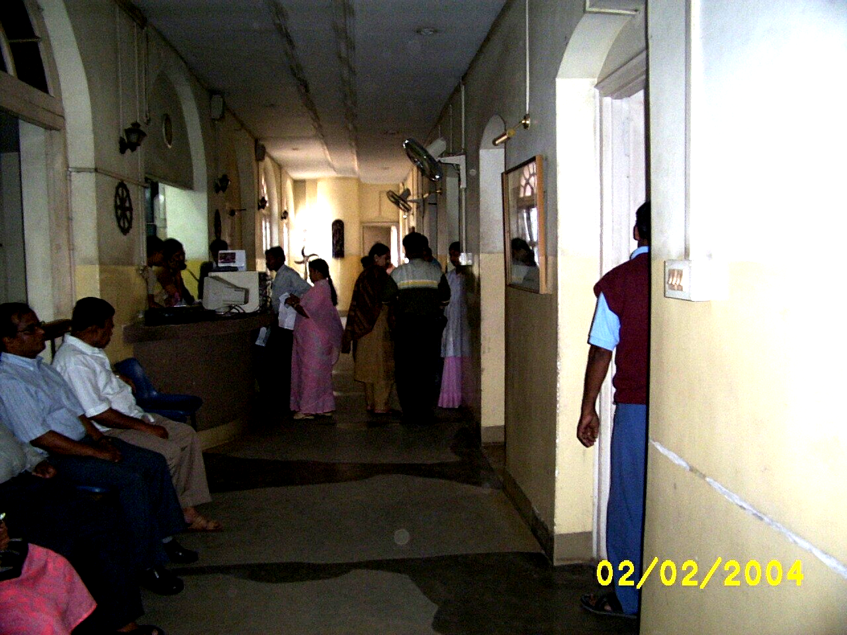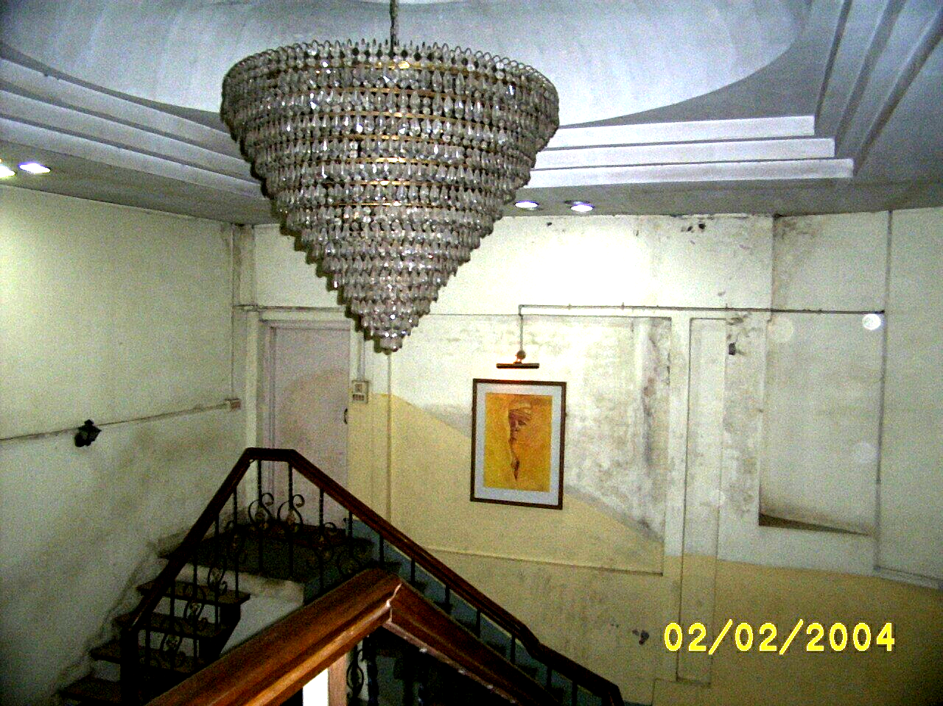

Sanjibon

Facilities and Departments

Facilities:

- Open on all days.

- Services rendered from 7.00 a.m. till 8.00 p.m.

- Sunday open from 7.00 a.m. till 5.00 p.m.

- Emergency and stat reports.

- 12 hrs continuous ultrasound, X-Ray and other imaging services.

- FNAC reports within 24 hrs.

- Home collection facilities.

- Emergency CT reports (within one hour).

- Appointments not necessary.

- Fully computerized and transparent Registration, billing and reporting.

- Computerized records available for three years.

Sanjibon

Departments:

- Radiology & Imaging: Spiral CT Scan, Digital Ultrasound, Color Doppler, High Powered X Ray, 0.3 T MRI

- Cardiology: Neonatal and adult digital color Doppler, Echocardiography, Computerized TMT, 12 Channel ECG, 3- channel Holter.

- Pathology: Histopathology, Biochemistry, Hematology, Microbiology, Serology, Immunology, Hormones and drug assay.

- Gastroenterology: Video- endoscopy (Upper and Lower GI endoscopy).

- Neurology: 21- channel EEG.

- Pulmonology and allergology: Pulmonary function test and allergy test with vaccination.

Sanjibon

Radiology & Imaging:

The spiral CT Scan at Sanjibon is possibly one of the fastest in the city with a 1sec scan time and 1 mm slice thickness. A special array of detectors gives enhanced and sharp pictures and the equipment is highly suited for Hi-res scanning, vascular imaging and 3-D reconstructions apart from the usual routine scan procedures. A team of eminent radiologists headed by Prof. A.K. Duttamunshi does the reporting. Emergency CT reports are given within one hour of the scan.

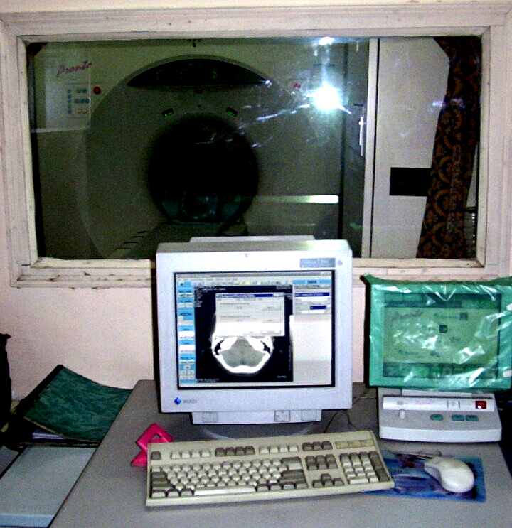

The 0.3 T MRI is possibly the highest strength permanent magnet MRI in the entire state. Capable of diffusion-weighted imaging and specially equipped with patented software for spine and joint cases, this is presently one of the most advanced MRI scan in the city. The reporting is done by Dr. R. Sain (MD), who has been specially trained in MRI at Milwaukee, USA. A team of junior radiologists ably assists Dr. Sain and the department also undertakes research and academic pursuits.

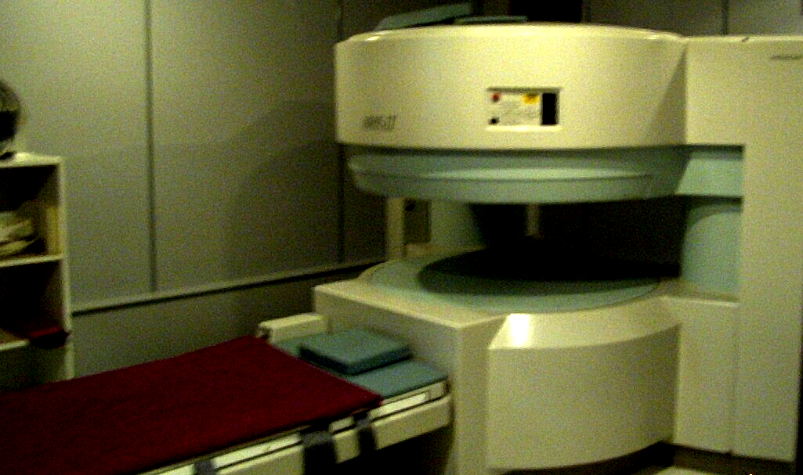

Digital Ultrasound & Color Doppler The Image Point HX and the Hitachi EUB 405 are capable of routine as well as specialized ultrasound examinations. Apart from TV and TR applications, Muskuloskeletal ultrasound detection of joint pathology and peripheral dopplers are undertaken in Sanjibon. Dr. B. Sil (Who is specially trained in USG of joints from Prof. Ramamurty), Dr. M.Bose, Dr. S. Pandey, Dr. G.Ganguly and Dr. S. M. Mukherjee comprises of our team of Radiologists performing USG.
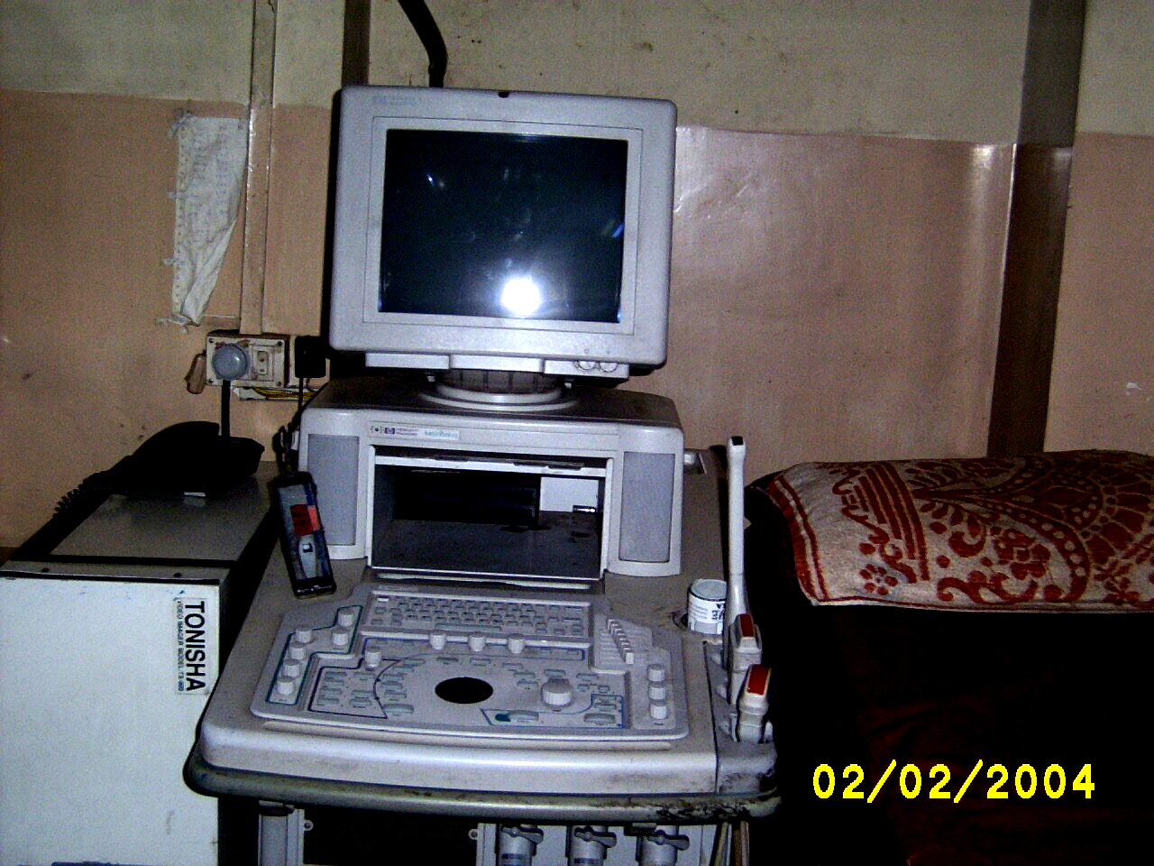

Sanjibon

High Powered X- Ray with Motorized Table is capable of all types of routine and specialized contrast studies, including Small bowel enema, I.V.P. Barium studies, Sialogram etc. A team of radiologists headed by Prof. A. K. Duttamunshi does the reporting. The presence of a team of senior radiologists enables emergency reports to be completed within one hour of the test.

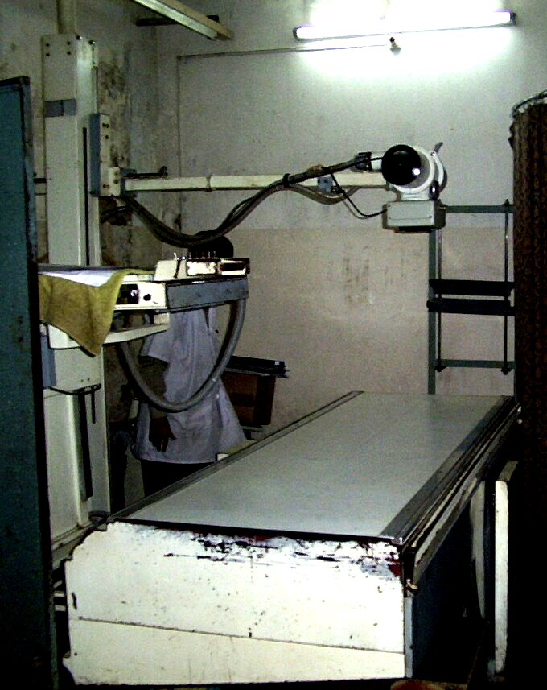

Cardiology:

Computerized TMT & 3-Channel Holter remains one of the dependable and accurate diagnostic tools in Sanibon. A team of cardiologists including Dr. G. Mistry (MD, DM), Dr. S. B. Roy (MD, DM) and Dr. S. Saha (MD) does the reporting. The equipment also performs 12- channel computerized ECG.

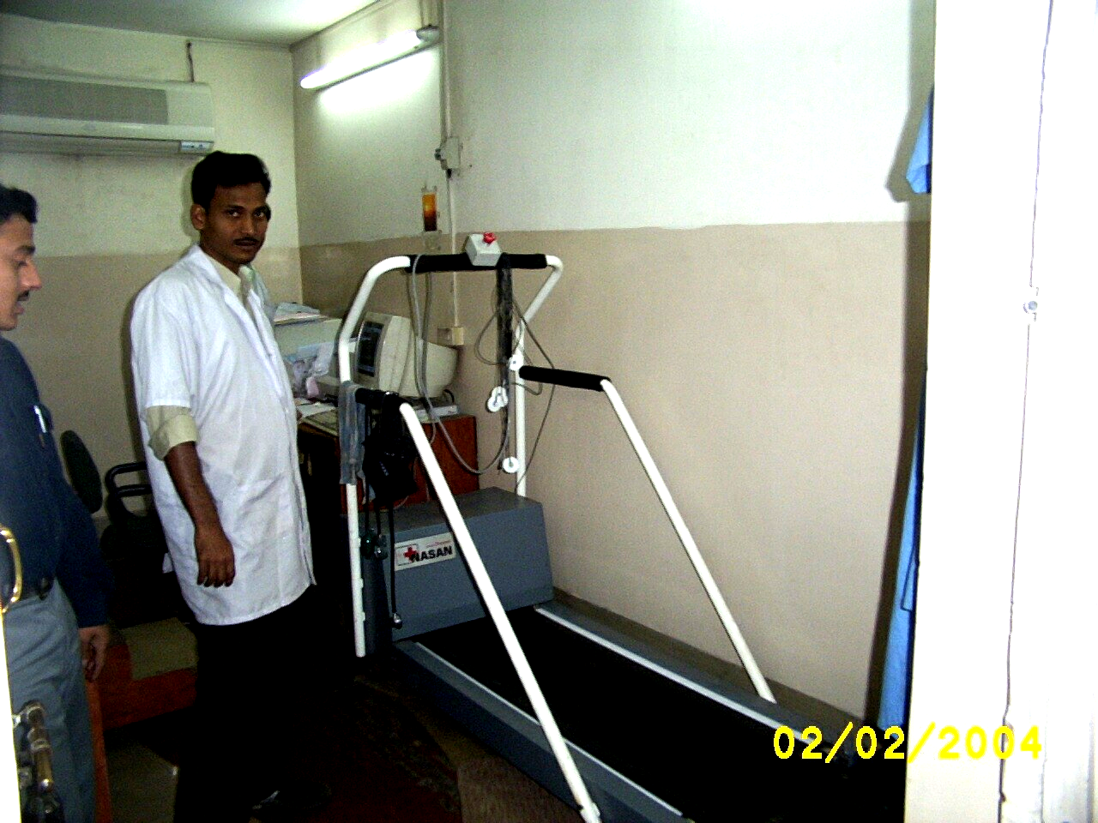

The Digital Color Doppler is one of the most advanced and hi-tech equipment. It is equipped with an array of specialized probes capable of routine Echocardiography and Neonatal, Pediatric and adult Color Doppler studies. A team of DM cardiologists performs the procedure.

Sanjibon

Pathology:

The Biochemistry Auto analyzer is from Boehringer and is the famous Hitachi 902. Capable of delivering 200 tests per hour the equipment runs on reagents imported from Germany. It gives precise and highly accurate results and has stat facilities. The advanced technology enables low amount of sample requirement and does away with manual involvement.

The Merck Semi-auto analyzer is the perfect back up to ensure continuity of service.

The Automated Hematology Analyzer is from Sysmex and is 99% precise in its reports. An advanced capillary mode enables to give complete Hemograms with pinprick drop of blood. It has a unique capability to do Thalassemia screening.

The Electro-Chemiluminiscent Elecsys 1010 does precise hormone analysis and delivers upto 100 reports in one hour. The Thyroid hormone results in Sanjibon are given within 12 hours.

Histopathology The department has been made famous by Dr. S. Mondol (MD—PGI Chandigarh), who is ably supported by a team of Pathologists and Microbiologists in other spheres.

Cytopathology This is the only department in the city that gives FNAC reports within 24 hours. This becomes invaluable for patients undergoing surgery. The organization is a referral institute for all guided FNAC.

Microbiology This department is specifically looked after by Dr. I. Chatterjee (Microbiologist) with 20 years of experience of handling the department with M/S Roy & Trivedi.

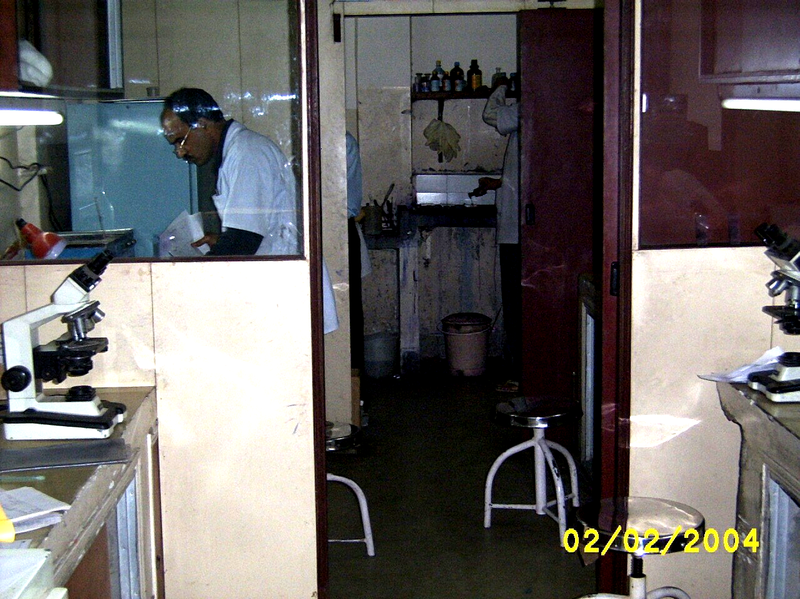

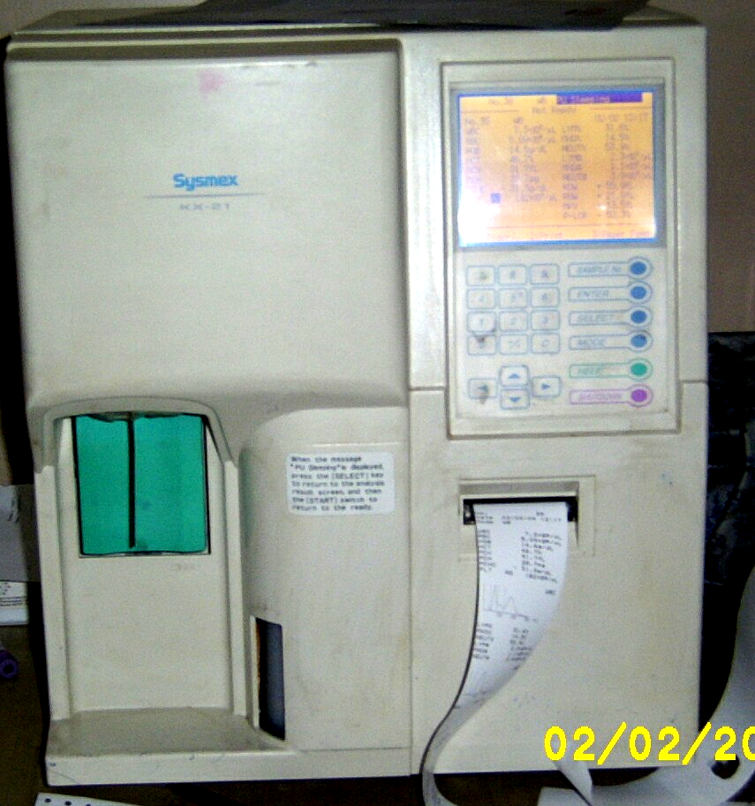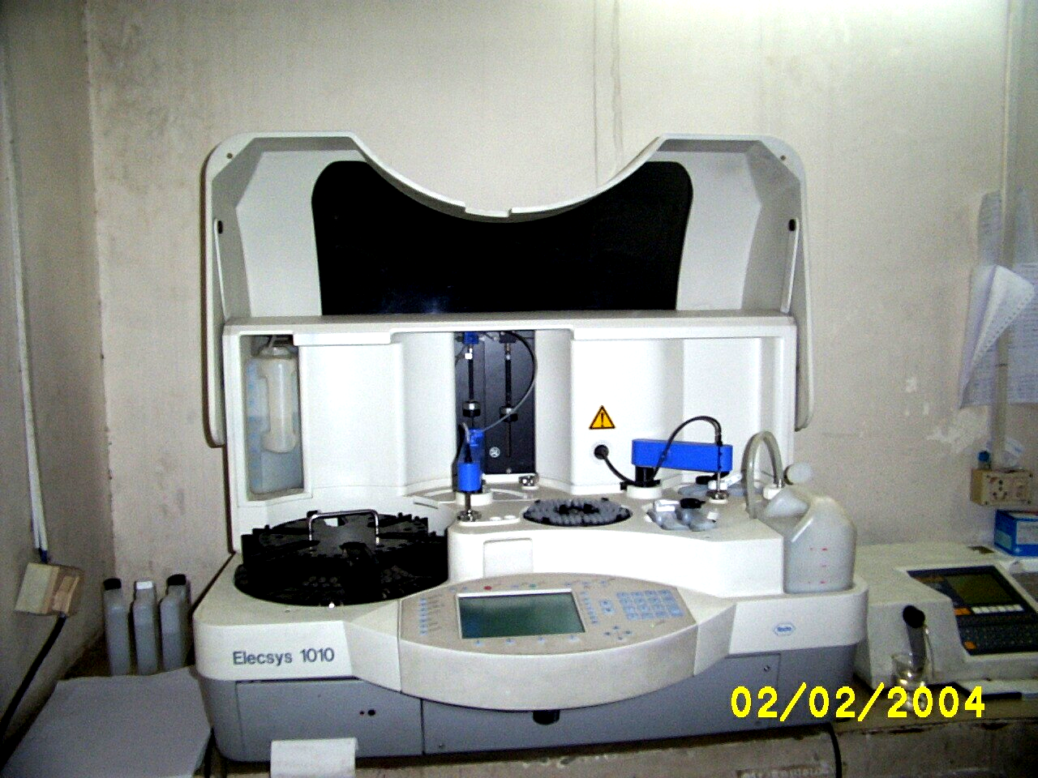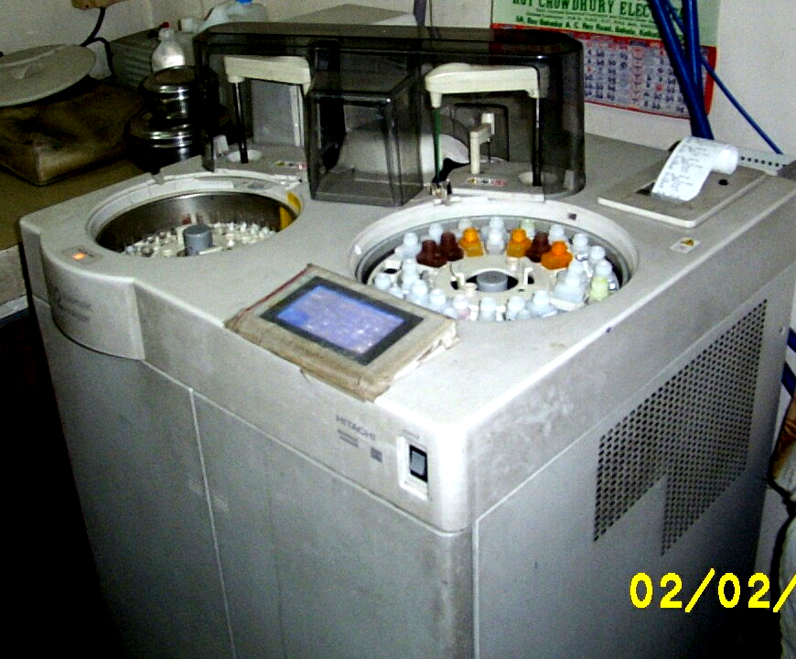

Sanjibon

Gastroenterology The department boasts of Video endoscopy procedures both for Upper and Lower Gastro intestinal tract. The department is looked after by Dr. D. Chowdhury (MD, FRCP) from USA and Dr. A. Shiva (MD, DM). Reports are delivered within one hour of the procedures.

Pulmonology and allergology: The department is looked after by Dr. S. Halder (MD) with more than 10 years of experience in the subject. The clinic treats more than 200 patients per month.

Neurology: The 21 channel EEG delivers accurate EEG reports, which are analyzed by a panel of four eminent, senior DM neurologists.

